Naming and Drawing Hydrocarbon Structures

Provide the IUPAC names for each of the following compounds. Indicate whether the hydrocarbon is either an aliphatic, cyclic, or aromatic hydrocarbon. If the hydrocarbon is aliphatic, or cyclic, indicate whether the hydrocarbon is an alkane, alkene, or alkyne. (3 marks each)

- 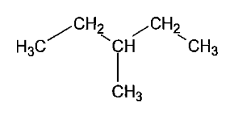  3-methylpentane  Aliphatic hydrocarbon  Alkane  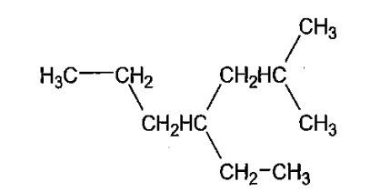 | - 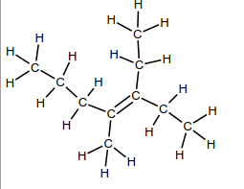  3-ethyl-4-methylhept-3-ene  Aliphatic hydrocarbon  Alkene
- 4-ethyl-2-methylheptane  Aliphatic hydrocarbon  Alkane | - Hept-3-ene  Aliphatic hydrocarbon  Alkene  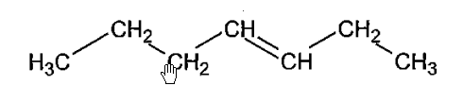
- 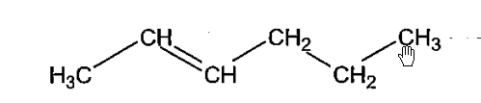  Hex-2-ene  Aliphatic hydrocarbon  Alkene | - 2,2-dimethylbutane  Aliphatic hydrocarbon  Alkane  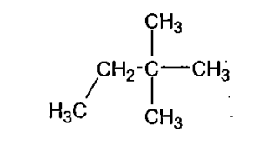
- 3-ethyl-3-methylpent-2-ene  Aliphatic hydrocarbon  Alkene  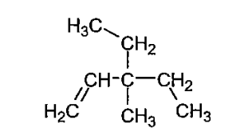 | - 3-ethyl-4-methylheptane  Aliphatic hydrocarbon  Alkane  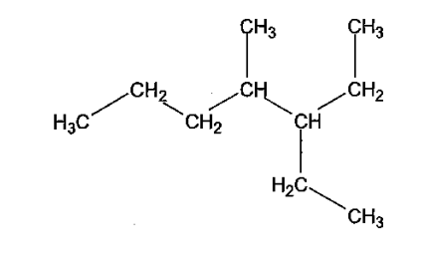
- 3-ethyl-4-methyloct-1-yne  Aliphatic hydrocarbon  Alkyne  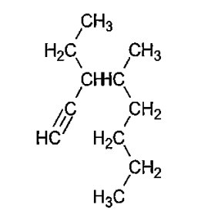 | - 3-ethyltoluene  Aromatic hydocarbon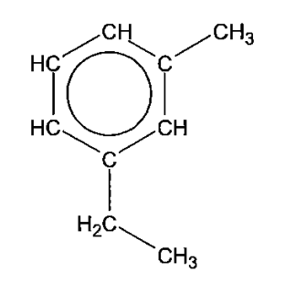
- 3-methyloctane  Aliphatic hydrocarbon  Alkene  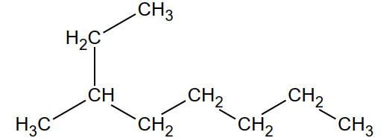 | - 4,5,6-triethylnonane  Aliphatic hydrocarbon  Alkene  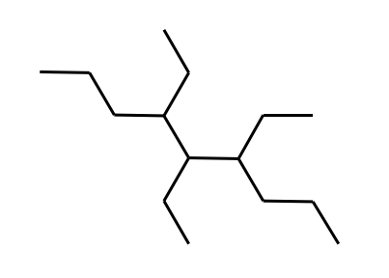
- 3-ethyl-5-methyl-3-propylhex-2-ene  Aliphatic hydrocarbon  Alkene  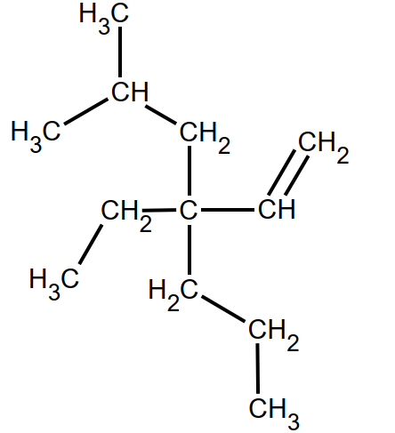 | - 4-propyl-4-octene  Aliphatic hydrocarbon  Alkene  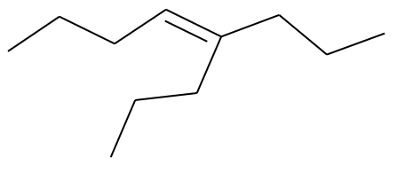
- 4-methylpent-1-yne  Aliphatic hydrocarbon  Alkyne  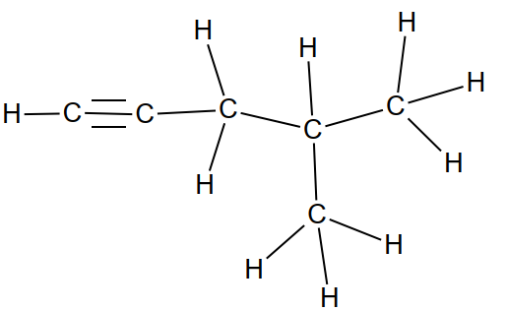 | - 3-ethyl-5-methyl-3-propylhexene  Aliphatic hydrocarbon  Alkyne  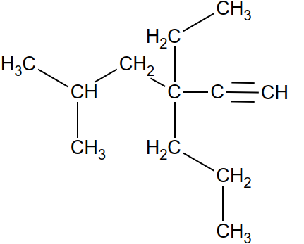

- 3-methylbutyne  Aliphatic hydrocarbon  Alkyne  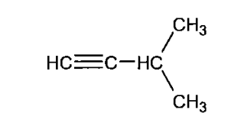 | - Cyclobutane  Cyclic hydrocarbon  Alkane  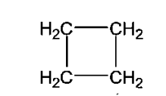
- 1,2-xylene  Aromatic hydrocarbon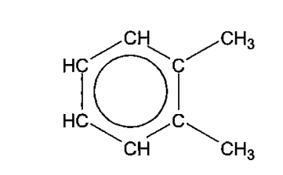 | - Ethynylbenzene  Aromatic hydrocarbon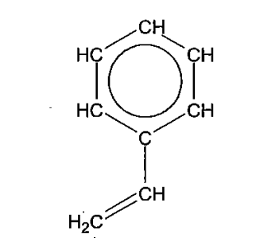
- Cyclopenta-1,3-dine  Cyclic hydrocarbon  Alkene  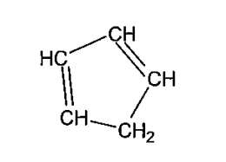 | - Cyclohexene  Cyclic hydrocarbon  Alkene  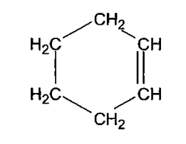
- 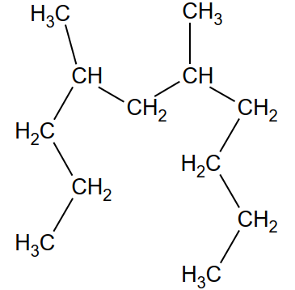 | - 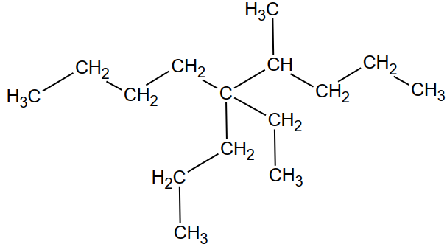
- 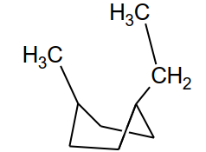 | - 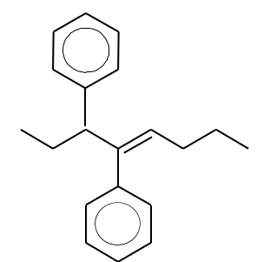

Draw condensed structural diagrams for the following compounds: (2 marks each)

- 3-methylhexane  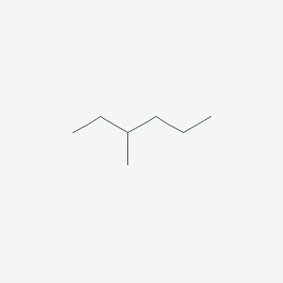 | - Methylpropene  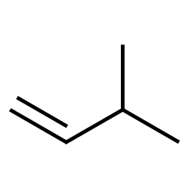
- 2,3-dimethylhexane  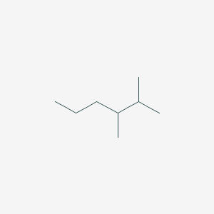 | - 3,4-dimethylhept-1-yne  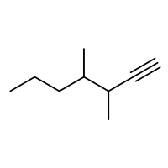
- 3-methyl-4-propylnonane  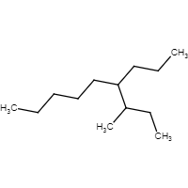 | - Cyclopentane  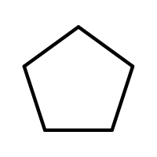
- 3,4-diethyl-3-methylheptane  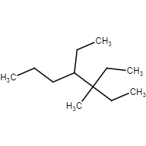 | - Methylcyclobutane  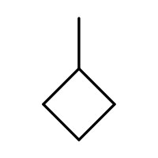
- Pent-1,3-diene  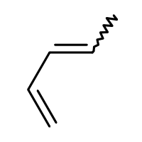 | - 4-ethyl-2-methylcyclohexene  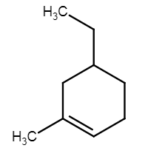
- 4-ethyl-4,6,6-trimethylnonane  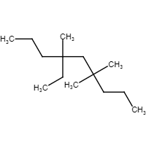 | - 2,2,3,3-tetramethyl-4-propylheptane  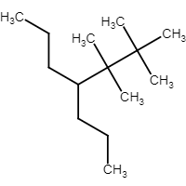
- 3-ethyl-4-methyl-3-propylhept-1-ene  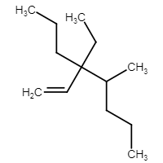 | - 2,2,5,5,6,6-hexamethylhept-3-yne  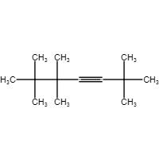

- 1,2-dipropylbenzene  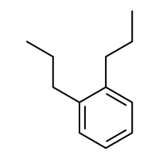 | - 1,3-diethylbenzene  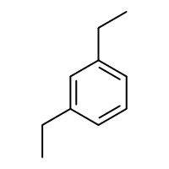
- 1,3,5-trimethylbenzene  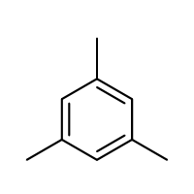 | - 1-methyl-4-propylbenzene  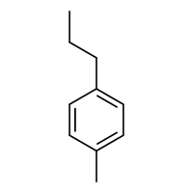

The following compounds names may or may not be correct. If they are correct, please write the condensed structural formula for the compound. If they are incorrect, please give the condensed structural formula and the proper IUPAC name. (3 each)

- 3,4-dimethylpentane  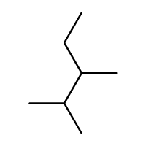 | - 1,2,4-methyl-3-ethylcyclohexane  1,2,4-trimethyl-3-ethylcyclohexane  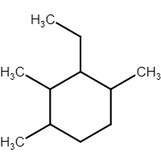
- 3-methyl-4-propylpentane  4-methylheptane  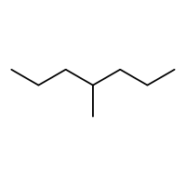 | - 1,1-dimethyl-2,2-diethylbutane  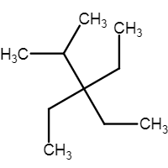
- 1,2-dimethyl-4,4-diethyloctane  3-methyl-5,5-diethylnonane  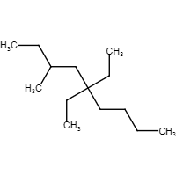 | - 1,3-dimethylpropane  Pentane  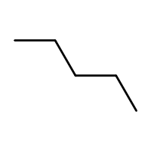

The boiling point of propane is -44.5°C and that of propene is -47.8°C. Is this consistent with the nature of the intermolecular forces present in both these hydrocarbons? Explain. (3 marks)

